|  |  |
| --- | --- |
| **Experiment Number** | **5** |
| **Date of Experiment** |  |
| **Date of Submission** |  |
| **Name** |  |
| **Roll Number** |  |
| **Section** | ECS-01 |

**Aim of The Experiment :-**

Familiarization with basic image processing techniques using LabVIEW.

**Equipment and Software Required:-**

The Equipment and Software required : LabVIEW

**Block Diagram for operations on image**

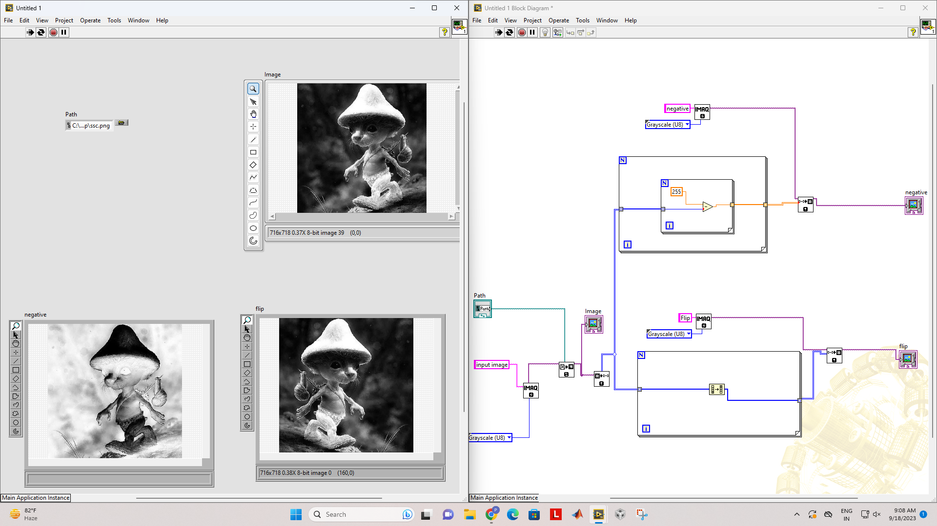



**Discussion or Inference of the experiment:**

Using LabVIEW, we created a circuit to perform basic image operations, such as inputting an image, converting it to grayscale, inverting its colors, and flipping it horizontally, using FOR loops for all array operations

**Conslusion:**

This exercise showed us how to use LabVIEW to make VIs, how to utilize IMAQ operations, how to use arrays for images, how to wire , how to generate image outputs, how to input images, how to use for loops, etc.